How to setup Figma and Design UI

Setup:

1. Download the Figma from [www.figma.com/downloads](http://www.figma.com/downloads).
2. Choose proper option for your operating system (macOS, Windows, iOS, Android).
3. Follow the steps for the license agreement.
4. Once complete, you may open Figma Application.
5. Sign up for Figma if not already have an account.

Design:

1. Open new window
2. Select desired frame for your UI design (ex: MacBook Pro 16” -1)

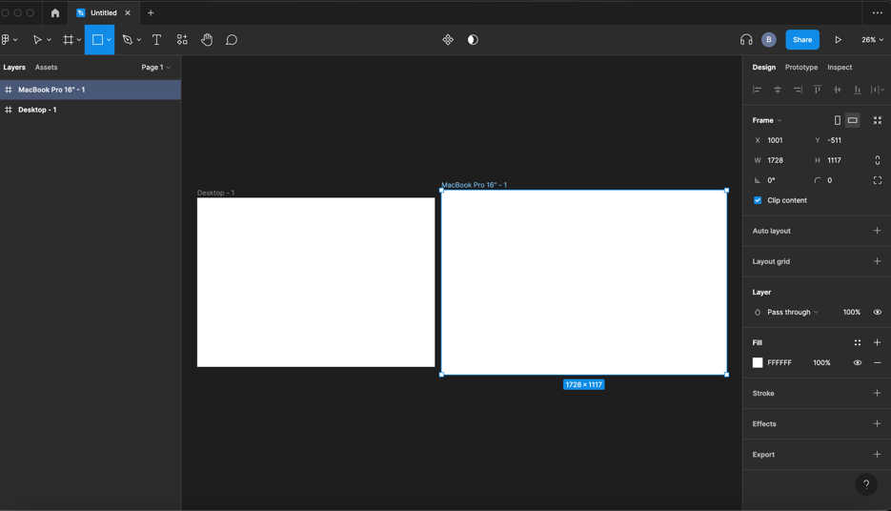

1. Once it open, select Shape tools, Rectangle

1. On the right-hand side, you see options like Design, Prototype, Inspect
2. When you select Rectangle you dragged, you may change color in Design tab
3. You can write Text by selecting T symbol and drag box to write in it.

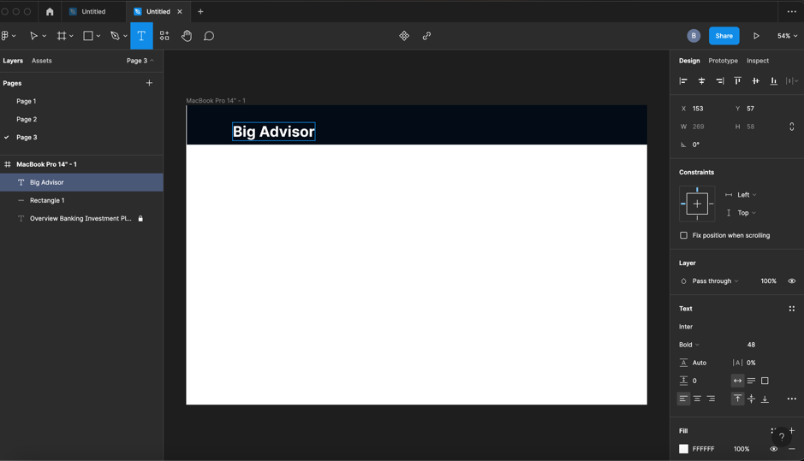

1. You may select different shape form shape tool options and texts to write simple design
2. Steps will be repeated, and you can enhance your design however you like

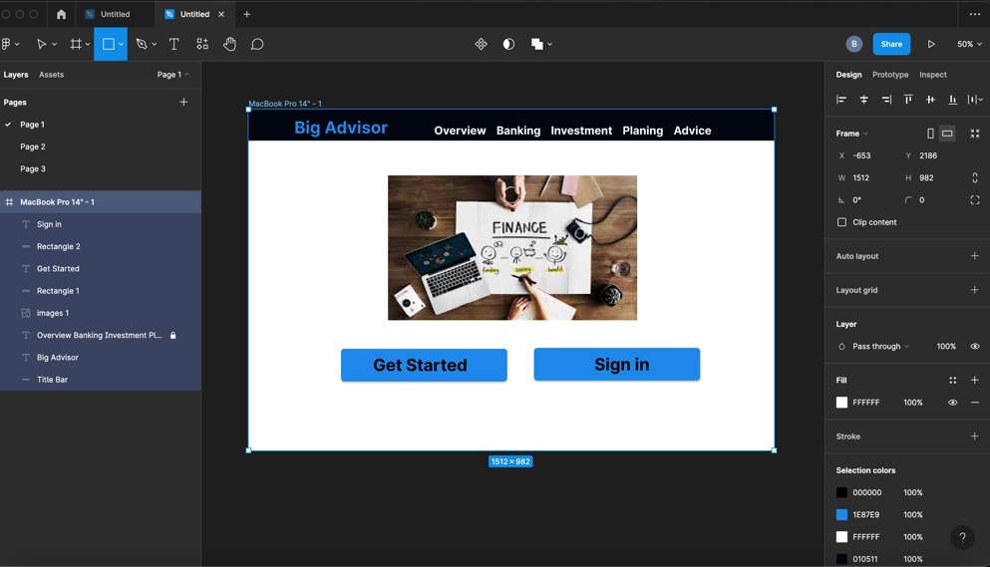

1. You may insert picture from different files, (png, jpeg, or screen shots)